

|  |  |  |
| --- | --- | --- |
|  | **Mathematics Department**  **11 Maths Methods Test 6 Even**  **Introduction to Differentiation** | |
| **Name** |  |

**Section 1 – Resource Free – Students can have the formula sheet**

**Marks : 31 Time: 33 minutes (maximum)**

**1:** **[2, 2, 2, 2, 3, 2 = 13 marks]**

Differentiate each of the following with respect to ‘x’.

Write answers with positive indices and do obvious simplification

a) y = x5 + 4x2 – 8x + 3 b) g(x) = 

c) f(x) = (8 – x)(5x2 + 7) d) y = (3 – 5x)2

e) y =  f) y = 

**2: [2 marks]**

State one function whose derivative is **2x – 1**.

**3. [4 marks]**

Find the equation of the tangent line to the curve **y = 2x3 – x2 + 6**

at the point **(-1,3)**.

**4. [2, 1, 1, 2 = 6 marks]**

Given y = (2x + 1)2 and u = 2x + 1, find:

a) 

b) 

c) y in terms of u.

d)  in terms of x

**5. [5 marks]**

Below is a graph of y = f(x)

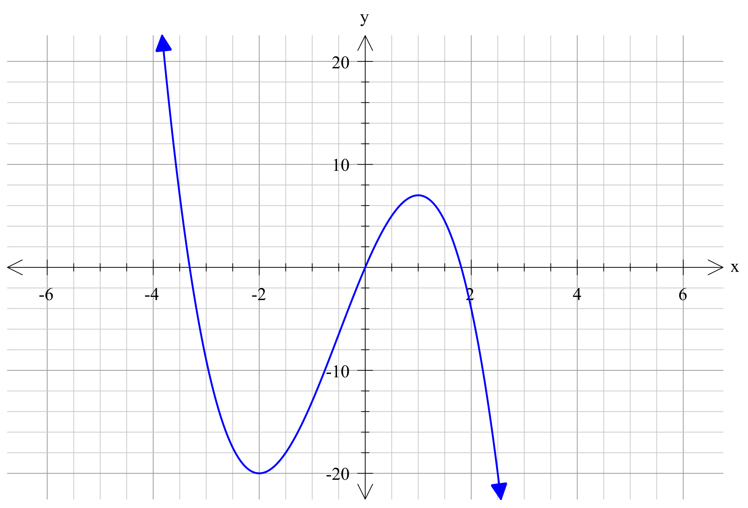

a) State the value(s) of x for which:

i) f ‘ (x) < 0

ii) f ‘ (x) = 0

iii) f ‘ (x) > 0

b) On the grid above, draw a possible graph of y = f ‘ (x)

**6. [2 marks]**

Below is a graph of y = g ‘ (x)

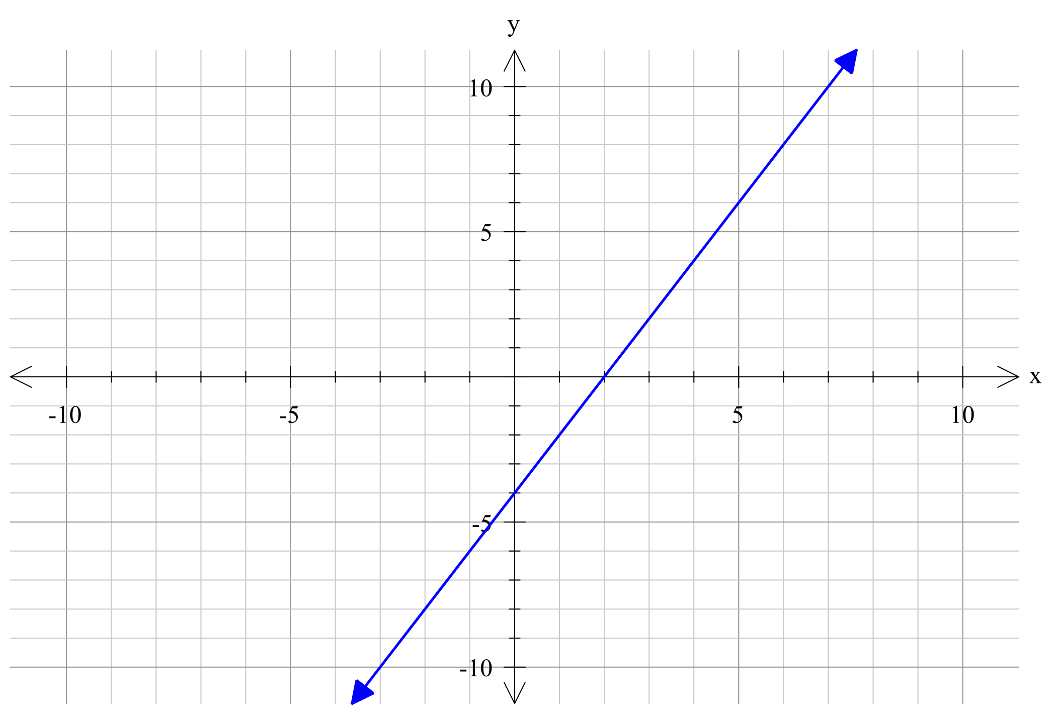

On the grid above, draw a possible graph of y = g(x)



|  |  |  |
| --- | --- | --- |
|  | **Mathematics Department**  **11 Maths Methods Test 6 Odd**  **Introduction to Differentiation** | |
| **Name** |  |

**Section 2 – Resource Rich – calculators, formula sheet and 1 page of notes**

**Marks : 25 Time: 27 minutes (minimum)**

**1. [5, 2 = 7 marks]**

a) Given the function f(x) = 5x3, complete the following table:

|  |  |  |
| --- | --- | --- |
| Point P | Point Q | Gradient of PQ (3 decimal places) |
| (2, 40) | (3, 135) |  |
| (2, 40) | (2.1, ) |  |
| (2, 40) | (2.01, ) |  |
| (2, 40) | (2.001, ) |  |

b) Find the value of the gradient to the curve f(x) = 5x3, at the point (2, 40)

**2.** **[4 marks]**

Given f(x) = 6x – 3, find:

a) f(x + h)

b) Show that 

**3. [1, 3 = 4 marks]**

Given that f(t) = 4t3 – 2t, find:

a) f ‘ (t)

b) Hence, or otherwise, find when f ‘ (t) = 1

**4. [5 marks]**

Find the point(s) of intersection between the curves y = x2 + 2x + 3 and y = x2 - x + 6. Hence, find the equation of the tangent(s) to the curve y = x2 - x + 6 at the point(s) of intersection.

**5. [5 marks]**

y = 2x + 1 is a tangent to the curve y = ax3 + bx, at the point (1, 3). Find the values of a and b.